1. Odd String Difference

CODE:

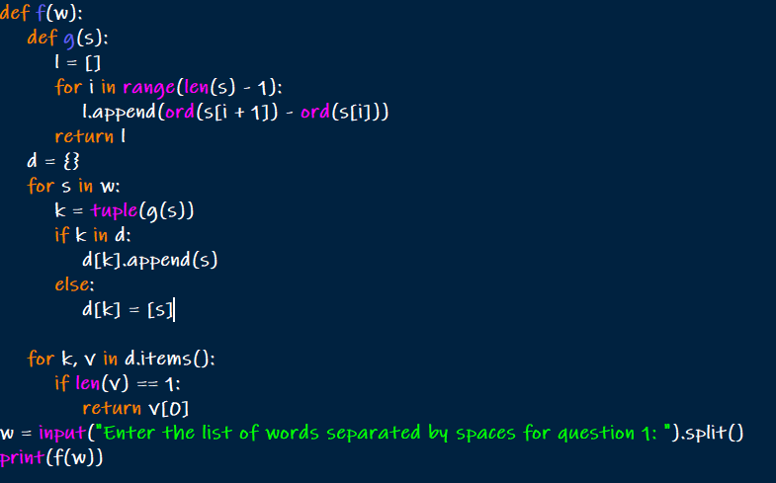

OUTPUT:



1. Words Within Two Edits of Dictionary

CODE:

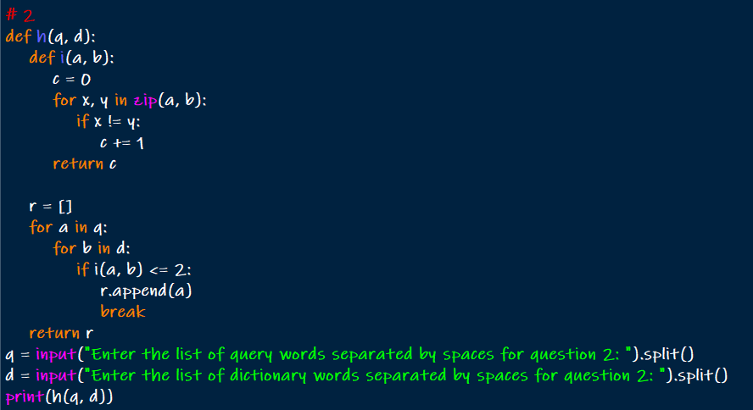

OUTPUT:



1. Destroy Sequential Targets

CODE:

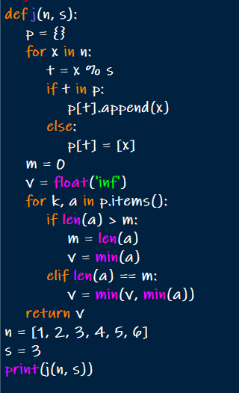

OUTPUT:



1. Next Greater Element IV

CODE:

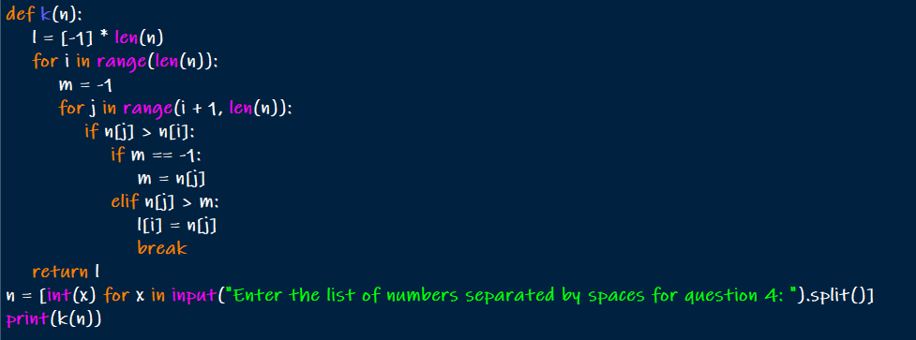

OUTPUT:



1. Average Value of Even Numbers That Are Divisible by Three

CODE:

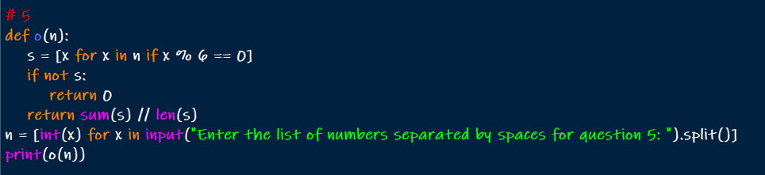

OUTPUT:



1. Most Popular Video Creator

CODE:

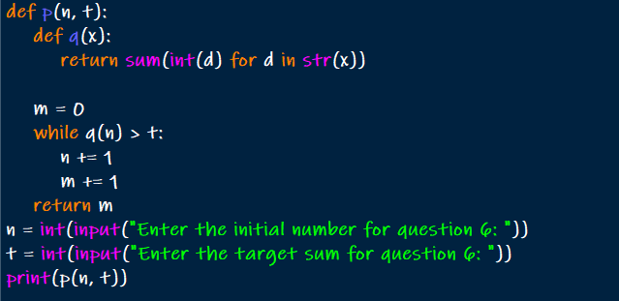

OUTPUT:

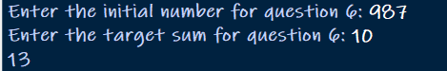

1. Minimum Addition to Make Integer Beautiful

CODE:

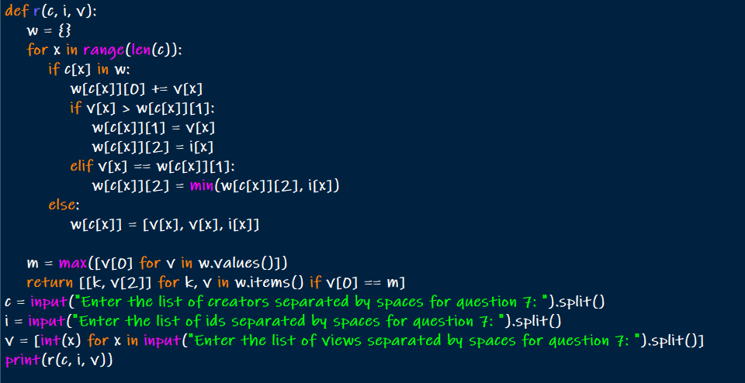

OUTPUT:

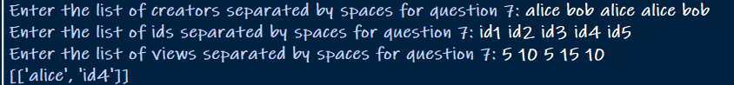

1. Split Message Based on Limit

CODE:

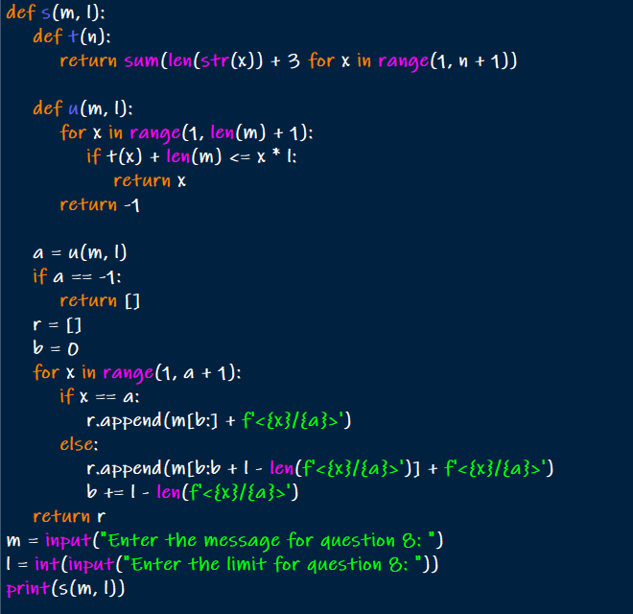

OUTPUT:

